|  |  |
| --- | --- |
|  |  |

电子线路设计与测试

第二阶段

MOSFET共源放大电路设计

安装、调试及测试

电子线路设计与测试

MOSFET共源放大电路设计

安装、调试及测试

（1）单级MOSFET共源放大电路仿真  
教材3.3.3实验任务3——实验步骤与要求（6）

（2）单级MOSFET共源放大电路插板实现  
教材3.3.3实验任务3——实验步骤与要求中的（1）-（5）。补充：观察失真现象

|  |  |
| --- | --- |
| **2** |  |

自学内容

□ 第2章 电子线路计算机辅助分析与设计

◼ 2.1 Orcad9.2软件概述  
◼ 2.2 Orcad9.2电路设计仿真分析的流程  
◼ 2.3 电子线路分析示例（2.3.1,2.3.4）

□ 第3章 模拟电子线路基础实验

◼ 3.2 双极结型三极管的参数测试与基本应用  
◼ 3.3 金属-氧化物-半导体场效应管参数测试与基本

应用

□ 第4章 模拟电子线路应用设计

◼ 4.2 双极结型晶体管共射放大器设计  
◼ 4.3 金属-氧化物-半导体场效应管放大器设计

线上教学资源

□ 华中科技大学《电子线路设计、测试与实验

（一）》MOOC课程：

|  |  |
| --- | --- |
| [□](http://www.icourse163.org/course/HUST-1001942004) [http://www.icourse163.org/course/H](http://www.icourse163.org/course/HUST-1001942004) | |
| [UST-1001942004](http://www.icourse163.org/course/HUST-1001942004)  □ 模块四、模块六 |  |

实验要点

▪ PSpice软件使用  
▪ MOSFET放大电路的设计方法  
▪ MOSFET放大电路静态工作点设置与调整方

法

▪ MOSFET放大电路性能指标的测试方法及调

试技术

▪ 了解负反馈对放大电路性能的影响

设计要求

3.3.3 实验任务3 P54

|  |  |  |  |
| --- | --- | --- | --- |
| |  | | --- | | ◼已知条件  ⚫**+*V*CC=+12V** ⚫***R*L=5.1k** ⚫***V*i=10mV(**有效值**)**⚫***R*si=50** | | |  | | --- | | ◼技术指标要求  ⚫***|A*V|**＞**10** ⚫***R*i** ＞ **50k** ⚫***R*o**＜**5.1k** ⚫***f*L**＜**100Hz** ⚫***f*H**＞**100kHz** ⚫电路稳定性好。 | |
|  |  |

|  |  |
| --- | --- |
|  |  |

电路设计一般流程(参见教材4.3节)

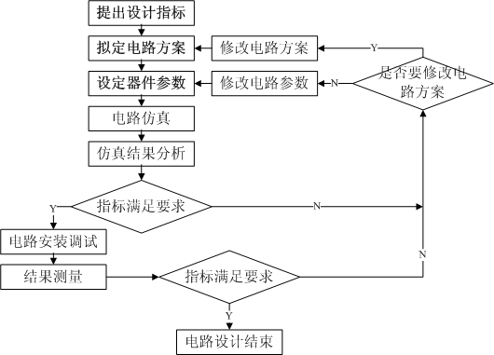

电路设计举例

|  |  |  |  |  |  |  |  |  |  |  |  |  |  |  |  |  |  |  |  |  |  |  |  |  |  |  |  |  |  |  |  |  |  |  |  |  |
| --- | --- | --- | --- | --- | --- | --- | --- | --- | --- | --- | --- | --- | --- | --- | --- | --- | --- | --- | --- | --- | --- | --- | --- | --- | --- | --- | --- | --- | --- | --- | --- | --- | --- | --- | --- | --- |
| □ 参见教材4.3节 |  | ***V*DD**  **12V**   |  |  |  |  |  |  |  |  |  |  |  |  |  |  |  |  |  | | --- | --- | --- | --- | --- | --- | --- | --- | --- | --- | --- | --- | --- | --- | --- | --- | --- | | |  |  | | --- | --- | | ***R*P**  **470k**  ***R*g1** | | | ***C*1** | **100k** |   **1** **F**  ***R*g2**  **100k** | | | | **5.1k**  ***R*d**   | | | |  |  | | --- | --- | | **T** | ***C*2**  **+**   **4.7** **F** |   **2N7000** | | | | | | | |  |  |  | |  |  |  |  |  |  |  | |  |  |  |  |  |  |  | |

OrCAD功能概述

OrCAD是美国OrCAD System公司推出的著名的EDA

软件，它是一个软件包，覆盖了电子设计的4项核心

任务

|  |  |  |  |  |  |  |  |  |  |
| --- | --- | --- | --- | --- | --- | --- | --- | --- | --- |
| OrC AD/C apture CIS  （电路原理图设计软件）  OrC AD/PSpice A/D   |  |  | | --- | --- | | OrC AD/Express Plus  (CPLD/FGPA设计软件) | （数/模混合模拟软件）  Optimizer  （电路优化设计） |   OrC AD/Layout Plus | | | | | |  | |
|
|  |  |
|  |  |
|  |  |
|  |  |
|  |  |
|  |  |
|  |  |
|  |  |  |  |  |  |  |  |

PSpice中的单位和数字

Pspice 中采用的是实用工程单位制，如电压用伏（V）、

电流用安培（A）、电阻用欧姆（Ω）、功率用瓦特（W）等。

在运行中，Pspice会根据具体对象自动确定其单位。用户在

输入数据时，代表单位的字母可以省去。例如给电压源赋值

时，键入12和12V意思一样。

Pspice 中的数字采用科学表示方式，即可以使用整数、

小数和以10为底的指数。用指数表示时，底数10用字母E来表

示。对于比较大或比较小的数字，还可采用10种比例因子，

如下表所示。

PSpice采用的比例因子

|  |  |  |  |  |
| --- | --- | --- | --- | --- |
| 符号 | 比例因子 |  | 符号 | 比例因子 |
| **F** | **10-15** |  | **M** | **10-3** |
| **P** | **10-12** |  | **K** | **10+3** |
| **N** | **10-9** |  | **MEG** | **10+6** |
| **U** | **10-6** |  | **G** | **10+9** |
| **MIL** | **25.4**× **10-6** |  | **T** | **10+12** |

例如1000、1**E**3和1**K**都表示同一个数。

12

PSpice仿真步骤

|  |  |  |  |  |  |  |
| --- | --- | --- | --- | --- | --- | --- |
| 新建设计项目（project）  电路图生成（Capture） | | | 模拟结果分析（prober）  优化设计（Optimizer） | | | |
|
|
|
|  |  |  |
|  |  |  |
|  |  |  |
|  |  |  |
|  |  |  |
|  |  |  |
|  |  |  |
|  |  |  |
|  |  |  |

PSpice仿真步骤

1. 创建工程项目文件

2. 编辑电路原理图（画电路图）  
3. 设置仿真分析类型  
4. 仿真分析  
 5. 查看仿真输出结果

➢ 从输出文件中查看仿真结果__文本结果

➢ 用Probe程序观测__ 图形结果

用Capture CIS绘制电路图

|  |  |
| --- | --- |
| 1. 创建工程项目文件  选File/New/ Project | ➢ 在F盘下，建立  子 目 录 ， 如 F:\mos 。 注 意 ：目 录 名 和 文 件 名 不 能 有 汉 字 、空格等！ |

➢ 选 择 Analog or

Mixed A/D

15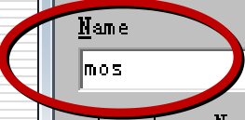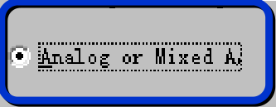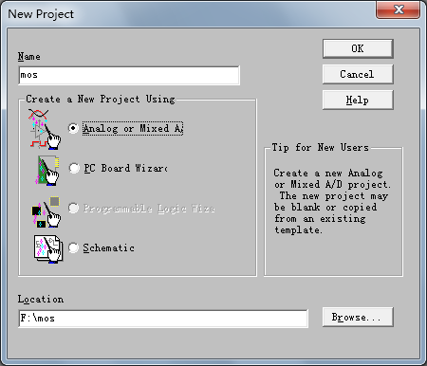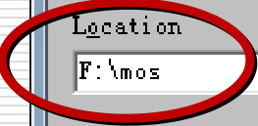

用Capture CIS绘制电路图

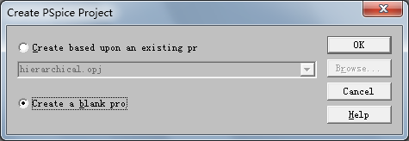

➢ 选择**Create a blank project**

用Capture CIS绘制电路图

|  |  |
| --- | --- |
| 项目管理器窗口 | 电路图编辑窗口 |

信息查看窗口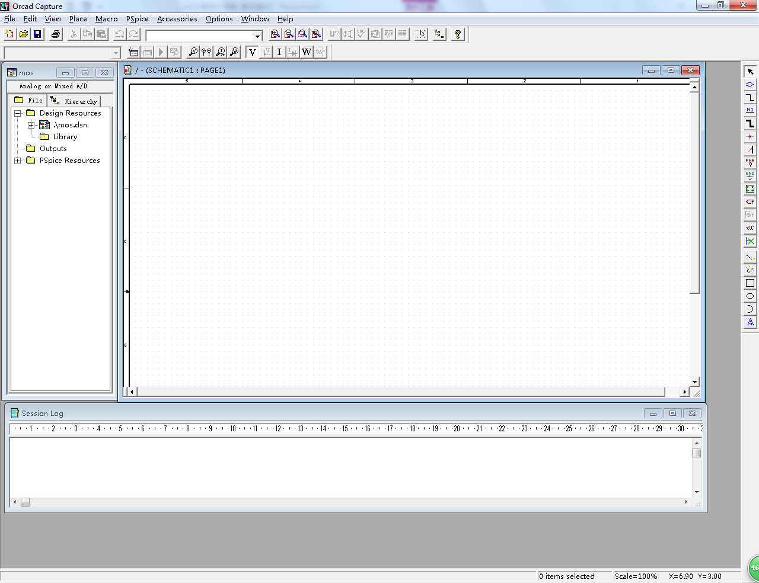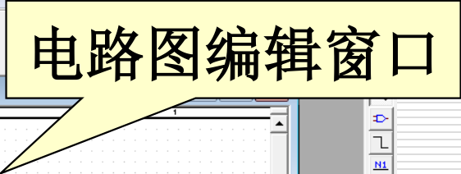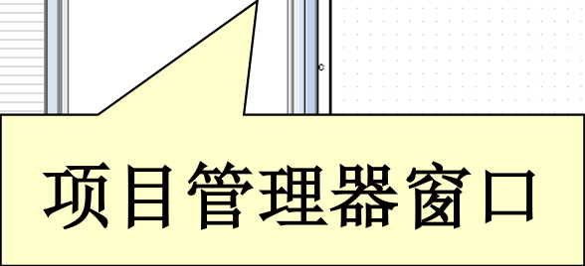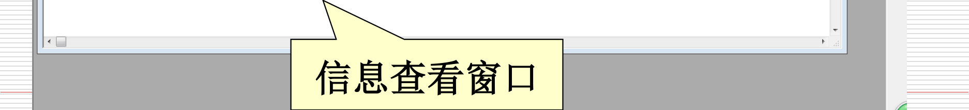

|  |  |
| --- | --- |
| 绘图快捷键 |  |

18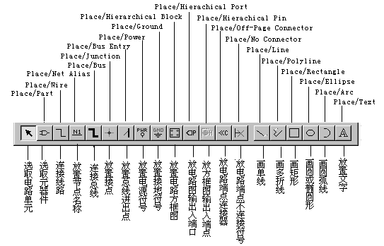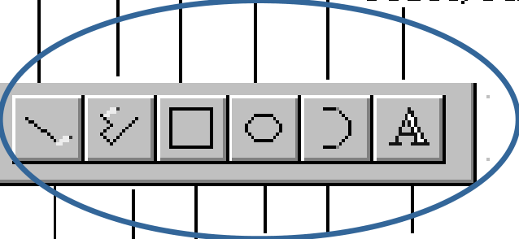

用Capture CIS绘制电路图

➢Place/Part命令或快捷键

（1）添加元件库： Analog 、pwrmos 、Source

|  |  |
| --- | --- |
|  |  |

（2）提取元件 ：如 m2n7000

用Capture CIS绘制电路图

➢取放电源与接地符号

|  |  |
| --- | --- |
| （1）取放电源符号 可同取放元器件一样，在SOURCE库中取电压源或电流源。  （2）取放接地符号 | |
| 启动Place/Groud，或按对应的绘图快捷键图所示的选择框。在SOURCE库中取“0”符号。 | ，出现如 |

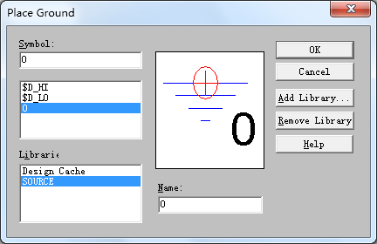

用Capture CIS绘制电路图

➢ 元件移动、旋转和删除

（1）选中元器件：用鼠标左键单击，此时元器件变为红色

（2）移动：压住鼠标左键拖到合适位置，松开鼠标左键

（3）旋转：菜单Edit/Rotate（或R）

（4）翻转：菜单Edit/mirror

（5）删除：选择菜单Edit/cut ；或按键Delete

注意选中元件后,鼠标右键的使用

用Capture CIS绘制电路图

|  |  |
| --- | --- |
| ➢连线：Place/Wire命令或快捷键 |  |

（1）画线：将光标移到需要连线的起点，单击左键（此时会拖着1根线）；移动鼠标到所需位置，单击左键，如此循环，直到连线的终点（某元件的引脚）

（2）结束：单击鼠标右键结束

（3）移动、旋转和删除：与元件操作相同

用Capture CIS绘制电路图

|  |  |
| --- | --- |
| ➢设置节点名：**Place/Net Alias**命令或快捷键 |  |

例如：想把输出端的节点起名为**Vo**。步骤如下：

①启动命令，屏幕上出现设置框，在设置框中键入节点名（例**Vo**）。

|  |  |
| --- | --- |
| ② 按**OK**键，则光标处  附着一个小方框，将光标  移至设置节点名的位置，  按鼠标左键，新节点名 |  |

即出现在该位置。

用Capture CIS绘制电路图

➢ 修改元器件标号和参数

方法1：选中元器件，选择菜单Edit/Properties

方法2：双击该元件符号或参数

|  |  |
| --- | --- |
| 特别注意！ | |
| ● | VSIN 信 号 源 ： AC=15mv 、 VOEF=0v 、 FREQ=1kHz 、 |

VAMPL=15mv。

|  |  |
| --- | --- |
| ● | MOS管参数设置方法： |

选择菜单Edit/Pspice Model ；

用Capture CIS绘制电路图

|  |  |
| --- | --- |
| 注意：此处和插 板电路不同 |  |

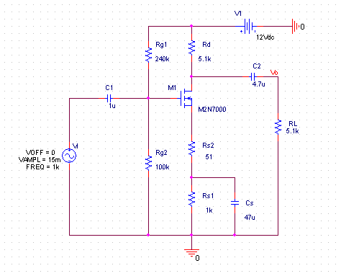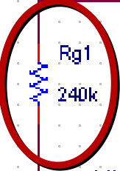

保存和自动检查

|  |  |
| --- | --- |
| ➢ 保存 | |
| ➢ | 进 行 电 路 规 则 检 查 、 建 立 网 表 文 件 |

（*.net） ：

Pspice/Create netlist  
若有问题，屏幕会有指示  
Windows/Session Log弹出错误提示窗口

设置分析类型

为了便于管理，OrCAD/PSpice 将基本直流分析、直流扫描

分析、交流分析和瞬态分析规定为4种基本分析类型。每一个模拟类型分组中只能包含其中的一种，但可以同时包括温度分析、参数扫描和蒙托卡诺分析等。

在电路图编辑窗口（Page Editor）下，点击PSpice/NewSimulation Profile命令或快捷键，出现New Simulation对

话框,在Name栏键入模拟类型组的名称，本例取名为 Bias

屏幕上出现模拟类型分组对话框。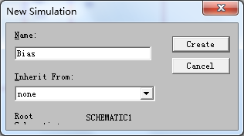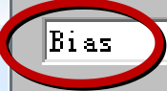

设置分析类型

|  |  |
| --- | --- |
| ➢ 静态工作点分析 | 输出文件更详细 |

静态工作点分析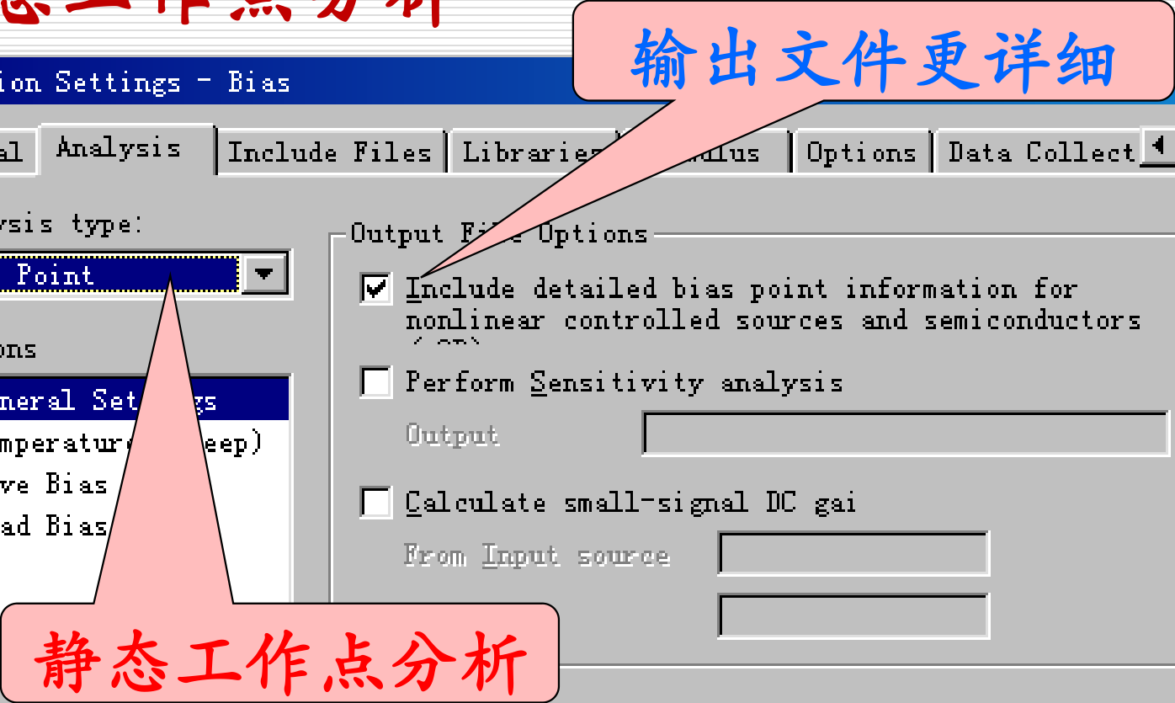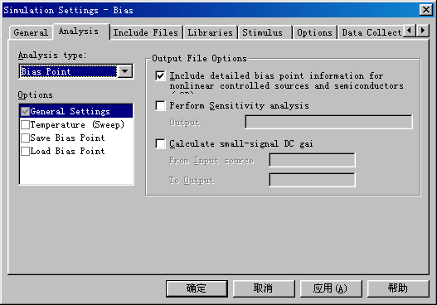

结果输出

➢ 运行Pspice

|  |  |
| --- | --- |
| 启动Pspice/Run命令或快捷键 |  |

➢ 查看分析结果

分析计算结束后，系统自动调用Probe模块，屏

幕上出现Probe窗口。选择View/Output File命令，即可看到本例的文本输出文件bias.out。

结果输出

|  |  |
| --- | --- |
| 输出文本文件 |  |

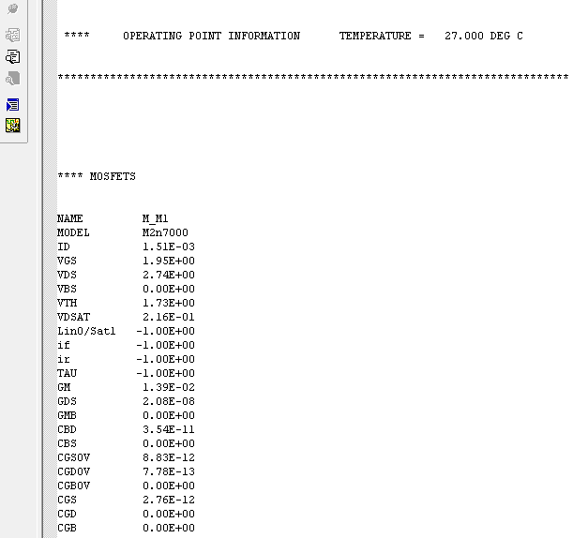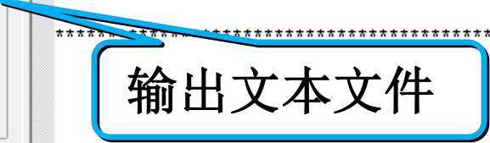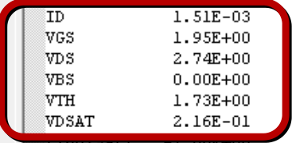

设置分析类型

➢ 瞬态分析（时域分析)

瞬态分析又称TRAN分析，就是求电路的时

域响应。它可在给定输入激励信号情况下，

计算电路输出端的瞬态响应，也可在没有激

励信号但有贮能元件（如C和L）的情况下，

求振荡波形。

设置分析类型

➢ 瞬态分析（时域分析)

|  |  |
| --- | --- |
|  | Run to: 4m 仿真终止时间为4ms  Start saving data:0仿真起始时间为0  Maximum Step：10us仿真时间步长为10s |

结果输出

|  |  |  |  |
| --- | --- | --- | --- |
| ➢ 启动Pspice/Run命令或快捷键 | |  | |
| ➢ 执行Trace/Add Trace命令或快捷键 | | |  |
|  |  | | |
|  |

结果输出

➢ 建立两个以上的波形显示区

① 在Add Trace 对话框中，选择V（Vo），点OK按钮，显示出输出端的波形。  
② 执行Plot/Add Plot to Window命令，屏幕上添加一个空白的波形显示区。  
③ 再执行Trace/Add Trace命令，在Add Trace 对话框选择V（Vi:+），点OK按钮，在新加的波形显示区显示出输入信号Vi的波形。

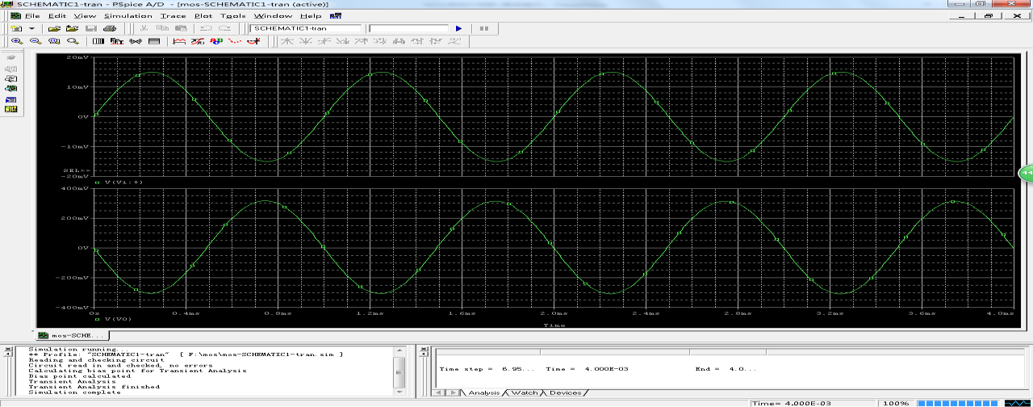

结果输出

|  |  |
| --- | --- |
| ➢ 注意特征值的标注 |  |

**注意：特征值的标注！**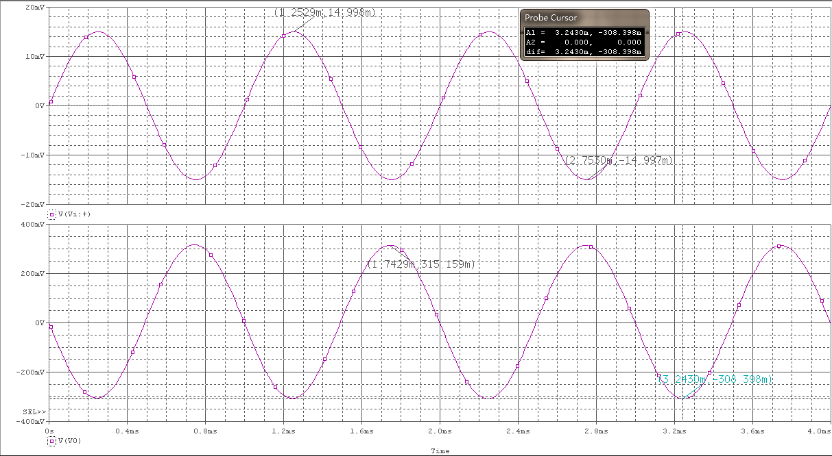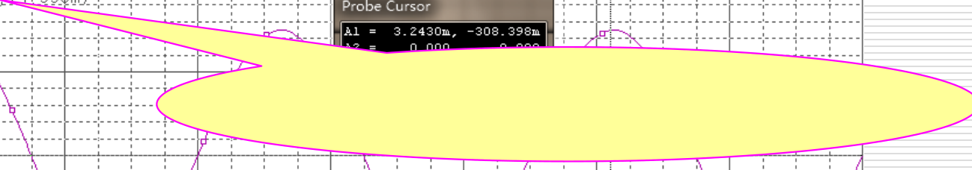

|  |  |
| --- | --- |
| 如何标注特征值 |  |

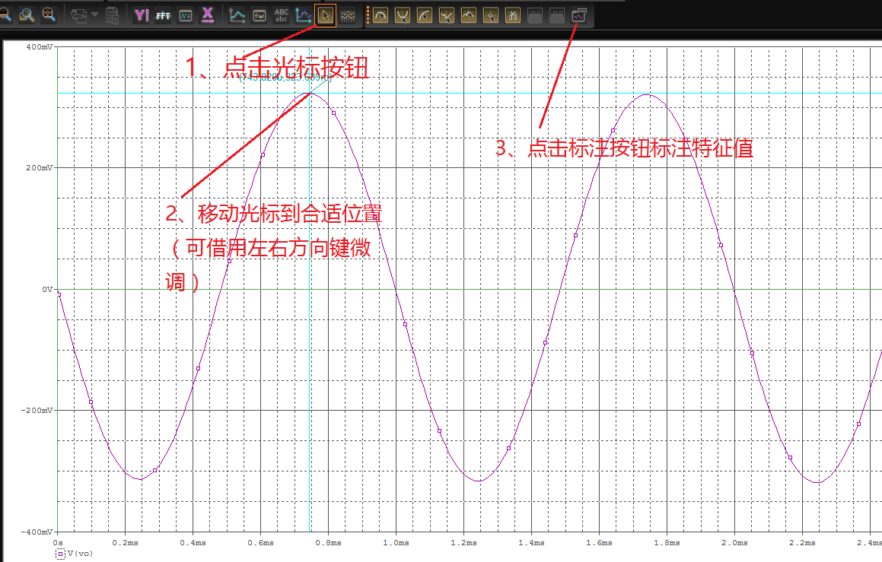

设置分析类型

➢ 交流分析（频域分析)

交流分析又称AC分析，就是求电路的频域响

应。当输入信号的频率变化时，它能够计算出电

路的幅频响应和相频响应。作交流分析时，应注

意：对于AC Sweep，必须具有AC 激励源。

设置分析类型

➢ 交流分析（频域分析)

|  |  |
| --- | --- |
|  | Start : 10  End：100meg  Points/Decade：101  Logarithmic： Decade |

设置分析类型

➢ 交流分析（频域分析)

故障原因分析---

No AC sources -- AC Sweep ignored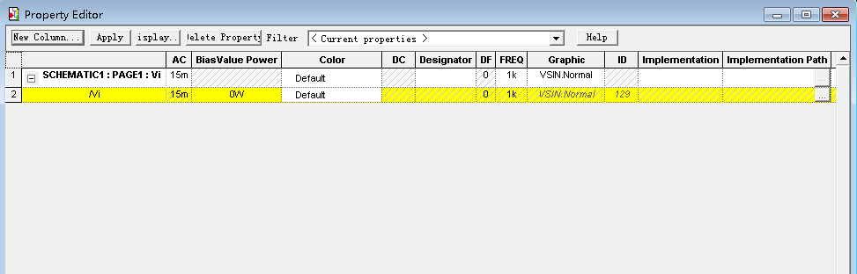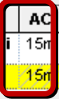

结果输出

➢ 击活AC Sweep, Pspice/Run  
➢ 观测幅频响应曲线：

➢ Trace/Add： db(V(Vo)/V(Vs:+))  
➢ Trace /Cursor/Display激活游标测中频增益  
➢ 用游标找到增益下降3dB ，对应频率为上限频率或下限

频率

➢ *观测相频响应曲线： P(V(Vo)/V(Vs+))  
➢ 观测输入电阻的频率响应：

➢ Trace/Add： Ri = V(Vi)/I(Vs)  
➢ Trace /Cursor/Display激活游标测中频输入电阻

结果输出

|  |  |
| --- | --- |
| ➢ 注意特征值的标注 |  |

**注意：特征值的标注！**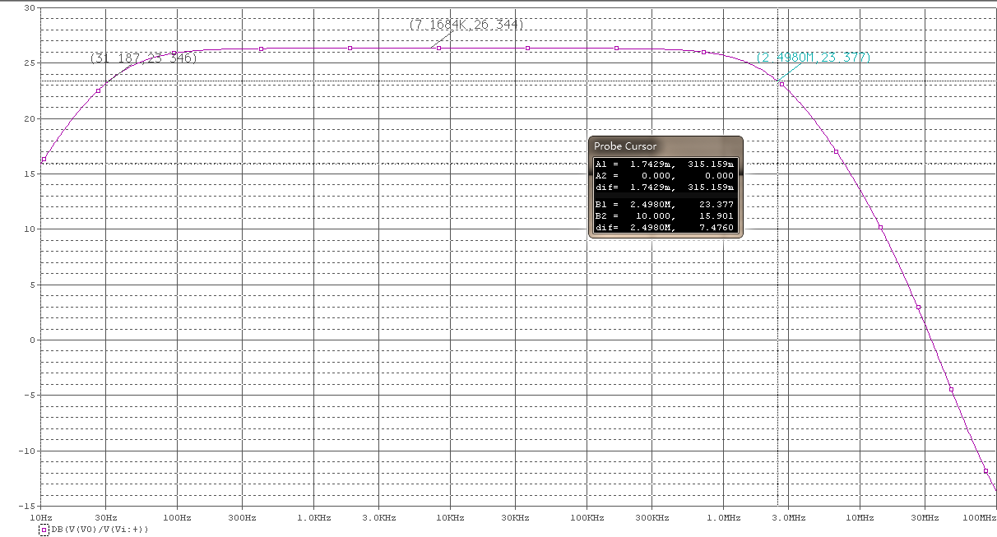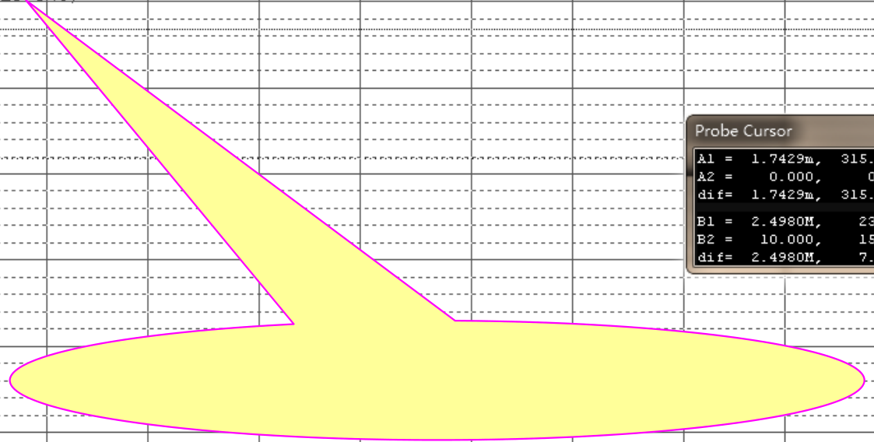

相频特性曲线

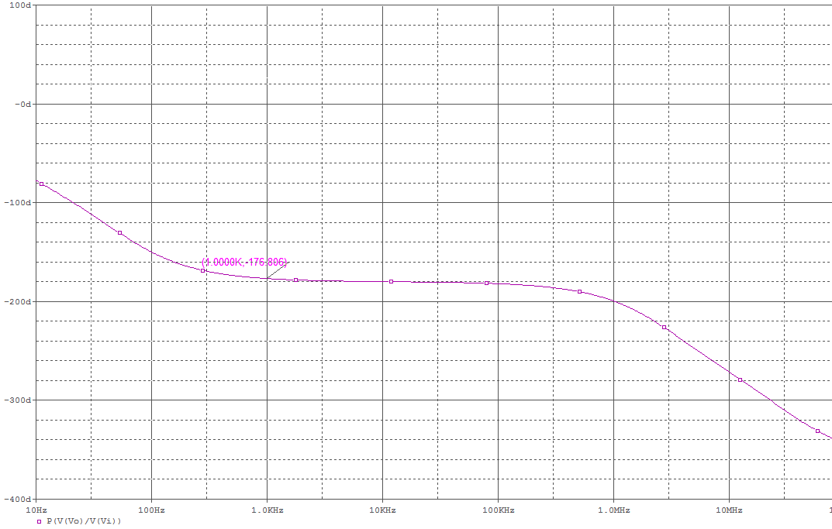

输入电阻频率响应

2021/11/1

43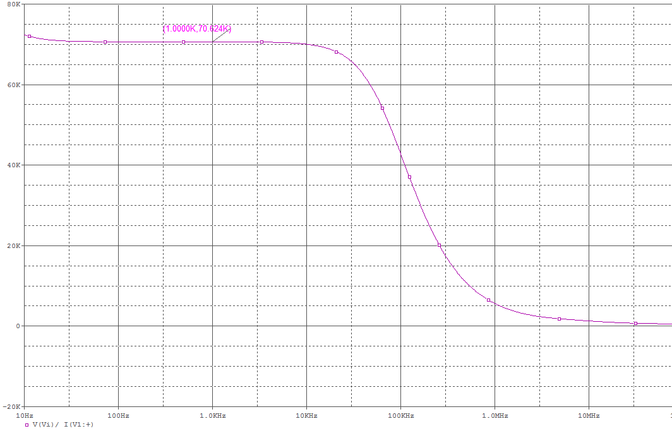

结果输出

➢ 求解输出阻抗

（**1**）修改电路：

令**Vi=0**，信号源短路，去掉负载**RL**，外加一个信号源**VSIN(400mv)**

（**2**）其他步骤与“输入电阻的频率响应”分析相同（**3**）**Ro =V(Vo)/I(C2)**

结果输出

➢ 求解输出阻抗

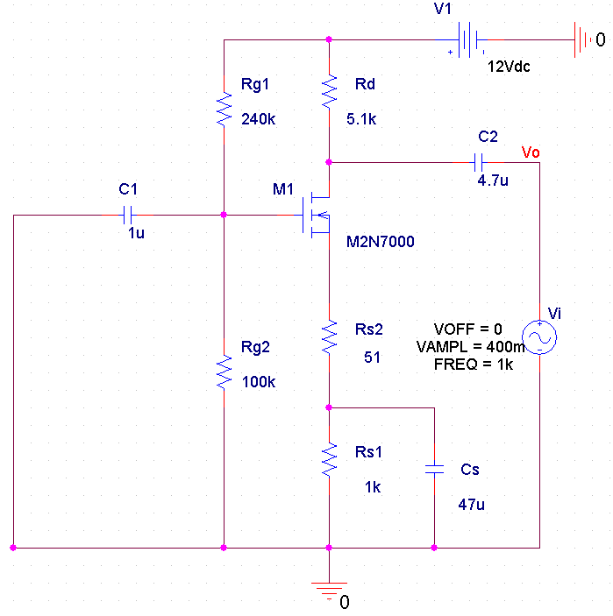

|  |  |
| --- | --- |
| 求解输出阻抗 |  |

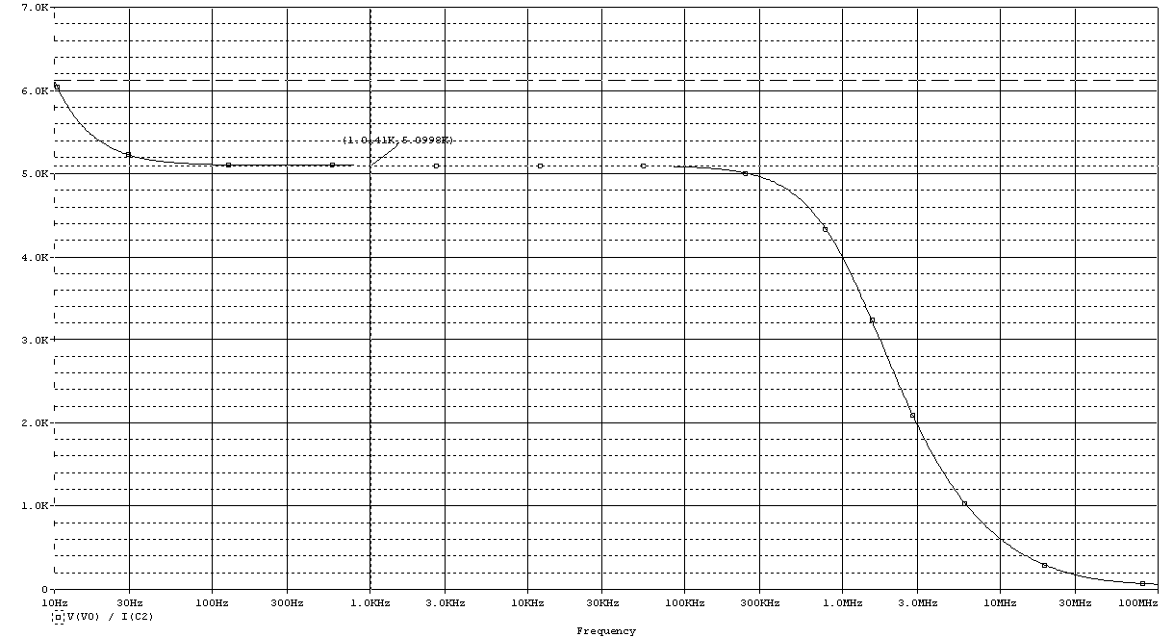

非线性失真现象



放大电路仿真验证设计要求

（**1**）电路图

（**2**）静态工作点：**ID**、**VGS**、**VDS**  
（**3**）输入、输出电压波形，并计算电压增益**Av**  
（**4**）幅频响应曲线：**db(V(Vo)/V(Vs:+))**，测中频增益、上限频

率**fH**和下限频率**fL**

（5）相频响应曲线：Vp(Vo)-Vp(Vs:+) 或 P(V(Vo)/V(Vs:+))

（**6**）输入电阻的频率响应：**Ri -- V(Vi)/I(Vi:+)**

（**7**）输出电阻的频率响应：**Ro-- V(Vo)/I(C2)**

（**8**）非线性失真现象

电路安装、调试与性能测试

|  |  |  |  |  |  |  |  |  |  |  |
| --- | --- | --- | --- | --- | --- | --- | --- | --- | --- | --- |
| 直流稳压电源 ＋－  ＋***V*** | | | | | | | 双踪  示波器 | | | |
|
|
|  |  |  |  |
|  |  |  |  |
|  |  |  |  |  |  |  |  |  |  |  |
|  |  |  |  |  |  |  |  |  |  |  |
|  |  |  |  |  |  |  |  |  |  |  |
|  |  |  |  |  |  |  |  |  |  |  |
|  |  |  |  |  |  |  |  |  |  |  |

电路的调试步骤

➢ 检查电路连接—磨刀不误砍柴工！

➢ 按照电路图来检查实际安装的线路  
➢ 特别注意：电源供电(包括极性)、信号源连线是否正确;

地线的共地问题；

➢ 静态测试；

➢ 静态工作点情况

➢ 动态测试；

➢ 基本信号输入输出情况

➢ 整机联调；

➢ 性能指标测试与电路参数调整

调试中的注意事项

**① 测试前，要熟悉电路的工作原理和各项技术指标的测试**

**方法。**

**② 注意仪器的信号线、地线的正确连接。**

**③ 测量电压时，所用仪器的输入阻抗必须远大于被测处的**

**等效阻抗。**

**④ 测量仪器的带宽必须大于被测电路的带宽，否则，测试结**

**果就有误差。**

**⑤ 测量方法要方便可行。**

**⑥ 调试过程中，不但要认真观察和测量，还要认真做好记录。**

52

电路安装

➢ 三极管识别与使用  
➢ 电路的安装方式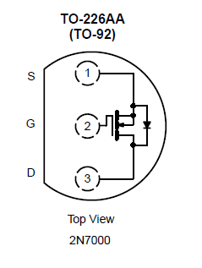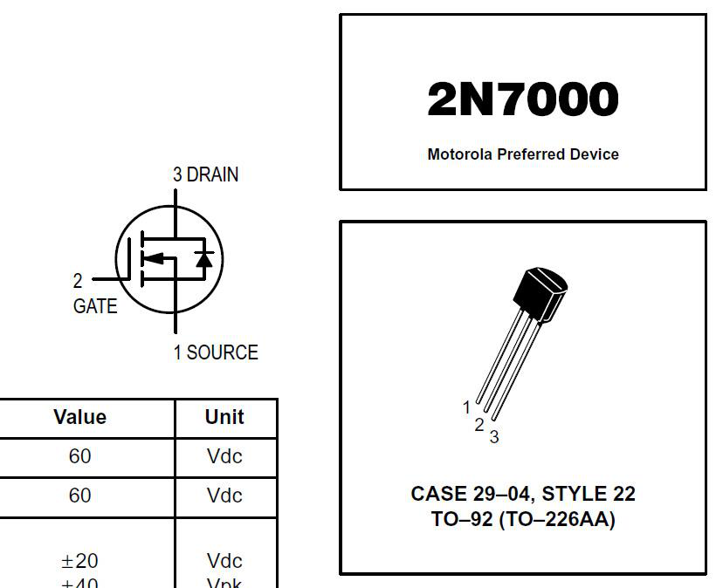

电路安装   
 **12V**  ***V*DD**  **+**  ***v*o**  －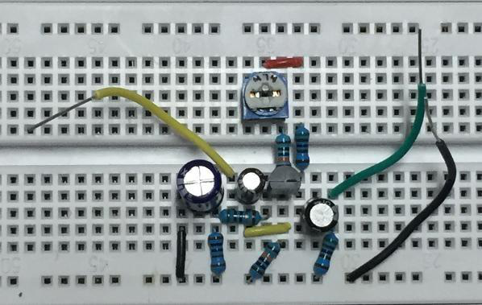  
 图 **3.3.6** 共源极放大电路

|  |  |  |  |  |  |  |  |  |  |  |
| --- | --- | --- | --- | --- | --- | --- | --- | --- | --- | --- |
| ***R*P** | | |  | ***R*** | | |  | | | |
|  |  |  |  |  |  |  |  |  |  |  |
|  |  |  |  |  |  |  |  |  |  |  |
|  |  |  |  |  |  |  |  |  |  |  |
|  |  |  |  |  |  |  |  |  |  |  |
|  |  |  |  |  |  |  |  |  |  |  |
|  |  |  |  |  |  |  |  |  |  |  |
|  |  |  |  |  |  |  |  |  |  |  |

电路调试（思路）  
➢ 静态工作点范围？

➢ 静态工作点未达到预期设计值的问题分析与解决

方法？

➢ 动态波形观察

➢ 输出波形失真的解决方法？

➢ 最佳静态工作点的调整

➢ 什么叫最大不失真？  
➢ 为什么要调整电路工作在最大不失真状态？➢ 如何调整电路到最大不失真状态？

性能测试

➢ 性能指标的测试与电路的调整：

➢ AV的测试；  
➢ 幅频特性的测试  
➢ Ri  
➢ Ro

➢ 特别注意：  
 交流信号**Vi** 和**Vo**的有效值及峰峰值只能用示波器测量，而不能用万用表。**---**？？？  
➢ 所有测试均应在波形基本不失真情况下测

量！

|  |  |  |
| --- | --- | --- |
| 测试静态工作点 |  |  |
| 连接好电路后，检查无误后接通 |  | ***V*DD**   |  |  |  |  |  |  |  |  |  |  |  |  |  |  |  |  |  | | --- | --- | --- | --- | --- | --- | --- | --- | --- | --- | --- | --- | --- | --- | --- | --- | --- | | |  |  | | --- | --- | | ***R*P**  **470k**  ***R*g1** | | | ***C*1** | **100k** |   **1** **F**  ***R*g2**  **100k** | | | | ***R*d 5.1k**   | | | |  |  | | --- | --- | | **T** | ***C*2**  **+**   **4.7** **F** |   **2N7000** | | | | | | | |  |  |  | |  |  |  |  |  |  |  | |  |  |  |  |  |  |  | |
|  |
|  |
|  |
|  |
|  |
|  |  |

性能测试

|  |  |  |  |  |  |  |  |  |  |  |  |  |  |  |  |  |  |  |  |  |  |  |  |  |  |  |  |  |  |  |  |  |  |  |  |  |  |  |  |  |  |  |  |  |  |  |  |  |  |  |  |  |  |  |  |  |  |  |  |  |  |  |  |  |  |  |  |  |  |  |  |  |  |  |  |  |  |  |  |  |  |  |  |  |  |  |  |  |  |  |  |  |  |  |  |  |  |  |  |  |  |  |  |  |  |  |  |  |  |  |  |  |  |  |  |  |  |  |  |  |  |  |  |  |  |  |  |  |  |  |  |  |  |  |  |  |  |  |  |  |  |  |  |  |  |  |  |  |  |  |  |  |  |  |  |  |  |  |  |  |  |  |  |  |  |  |  |  |  |  |  |  |  |  |  |  |  |  |  |  |  |  |  |  |  |  |  |  |  |  |  |  |  |  |  |  |  |  |  |  |  |  |  |  |  |  |  |  |  |  |  |  |  |  |  |  |  |  |  |  |  |  |  |  |  |  |  |  |  |  |  |  |  |  |  |  |  |  |  |  |  |  |  |  |  |  |  |  |  |  |  |  |  |  |  |  |  |  |  |  |  |  |  |  |  |  |  |  |  |  |  |  |
| --- | --- | --- | --- | --- | --- | --- | --- | --- | --- | --- | --- | --- | --- | --- | --- | --- | --- | --- | --- | --- | --- | --- | --- | --- | --- | --- | --- | --- | --- | --- | --- | --- | --- | --- | --- | --- | --- | --- | --- | --- | --- | --- | --- | --- | --- | --- | --- | --- | --- | --- | --- | --- | --- | --- | --- | --- | --- | --- | --- | --- | --- | --- | --- | --- | --- | --- | --- | --- | --- | --- | --- | --- | --- | --- | --- | --- | --- | --- | --- | --- | --- | --- | --- | --- | --- | --- | --- | --- | --- | --- | --- | --- | --- | --- | --- | --- | --- | --- | --- | --- | --- | --- | --- | --- | --- | --- | --- | --- | --- | --- | --- | --- | --- | --- | --- | --- | --- | --- | --- | --- | --- | --- | --- | --- | --- | --- | --- | --- | --- | --- | --- | --- | --- | --- | --- | --- | --- | --- | --- | --- | --- | --- | --- | --- | --- | --- | --- | --- | --- | --- | --- | --- | --- | --- | --- | --- | --- | --- | --- | --- | --- | --- | --- | --- | --- | --- | --- | --- | --- | --- | --- | --- | --- | --- | --- | --- | --- | --- | --- | --- | --- | --- | --- | --- | --- | --- | --- | --- | --- | --- | --- | --- | --- | --- | --- | --- | --- | --- | --- | --- | --- | --- | --- | --- | --- | --- | --- | --- | --- | --- | --- | --- | --- | --- | --- | --- | --- | --- | --- | --- | --- | --- | --- | --- | --- | --- | --- | --- | --- | --- | --- | --- | --- | --- | --- | --- | --- | --- | --- | --- | --- | --- | --- | --- | --- | --- | --- | --- | --- | --- | --- | --- | --- | --- | --- | --- | --- | --- | --- | --- | --- | --- | --- | --- | --- | --- | --- | --- | --- | --- | --- | --- |
| ➢ 测试放大电路的输入、输 |  | ***V*DD**  **12V**  **+**  **+**  ***v*o *v*i**   **−**  －   |  |  |  |  |  |  |  |  |  |  |  |  |  |  |  | | --- | --- | --- | --- | --- | --- | --- | --- | --- | --- | --- | --- | --- | --- | --- | |  |  |  |  |  |  |  |  |  |  |  |  |  |  |  | |  |  |  |  |  |  |  |  |  |  |  |  |  |  |  | |  |  |  |  |  |  |  |  |  |  |  |  |  |  |  | |  |  |  |  |  |  |  |  |  |  |  |  |  |  |  | |  |  |  |  |  |  |  |  |  |  |  |  |  |  |  | |  |  |  |  |  |  |  |  |  |  |  |  |  |  |  | |  |  |  |  |  |  |  |  |  |  |  |  |  |  |  | |  |  |  |  |  |  |  |  |  |  |  |  |  |  |  | |  |  |  |  |  |  |  |  |  |  |  |  |  |  |  | |  |  |  |  |  |  |  |  |  |  |  |  |  |  |  | |  |  |  |  |  |  |  |  |  |  |  |  |  |  |  | |  |  |  |  |  |  |  |  |  |  |  |  |  |  |  | |  |  |  |  |  |  |  |  |  |  |  |  |  |  |  | |  |  |  |  |  |  |  |  |  |  |  |  |  |  |  | |  |  |  |  |  |  |  |  |  |  |  |  |  |  |  | |  |  |  |  |  |  |  |  |  |  |  |  |  |  |  | |  |  |  |  |  |  |  |  |  |  |  |  |  |  |  | |  |  |  |  |  |  |  |  |  |  |  |  |  |  |  | |
|  |
|  |
|  |
|  |
|  |
|  |
|  |  |

性能测试

|  |  |  |  |  |  |  |  |  |  |  |  |  |  |  |  |  |  |  |  |  |  |  |  |  |  |  |  |  |  |  |  |  |  |  |  |  |  |  |  |  |  |  |  |  |  |  |  |  |  |  |  |  |  |  |  |  |  |  |  |  |  |  |  |  |  |  |  |  |  |  |  |  |  |  |  |  |  |  |  |  |  |  |  |  |  |  |  |  |  |  |  |  |  |  |  |  |  |  |  |  |  |  |  |  |  |  |  |  |  |  |  |  |  |  |  |  |  |  |  |  |  |  |  |  |  |  |  |  |  |  |  |  |  |  |  |  |
| --- | --- | --- | --- | --- | --- | --- | --- | --- | --- | --- | --- | --- | --- | --- | --- | --- | --- | --- | --- | --- | --- | --- | --- | --- | --- | --- | --- | --- | --- | --- | --- | --- | --- | --- | --- | --- | --- | --- | --- | --- | --- | --- | --- | --- | --- | --- | --- | --- | --- | --- | --- | --- | --- | --- | --- | --- | --- | --- | --- | --- | --- | --- | --- | --- | --- | --- | --- | --- | --- | --- | --- | --- | --- | --- | --- | --- | --- | --- | --- | --- | --- | --- | --- | --- | --- | --- | --- | --- | --- | --- | --- | --- | --- | --- | --- | --- | --- | --- | --- | --- | --- | --- | --- | --- | --- | --- | --- | --- | --- | --- | --- | --- | --- | --- | --- | --- | --- | --- | --- | --- | --- | --- | --- | --- | --- | --- | --- | --- | --- | --- | --- | --- | --- | --- | --- | --- |
| 串联一个 已知电阻  ***R***   |  |  |  |  |  |  |  |  |  |  |  |  | | --- | --- | --- | --- | --- | --- | --- | --- | --- | --- | --- | --- | | 图中R取值尽量与Ri接 | | | | | | | | | | | | |  |  | = |  | *v* | | *o* | 2 |  |  | • | *R* | | *R* | *i* |  | *v* |  | *v* | *o* | 2 |  |  | | 01 | − | | | |  |  |  |  |  |  |  |  |  |  |  | | --- | --- | --- | --- | --- | --- | --- | --- | --- | --- | --- | | 实验测试 | | | | | | | | | | | | ***R***   |  |  |  |  |  | | --- | --- | --- | --- | --- | | 信  号  源 |  | | | | | | ＋  *V*s    － |  | | ＋    *V*i  － | |  |  | |  |  |  |  | | | | | | | | |  |  |  | |  |  |  | |  |  |  | |  |  |  |  |  |  |  |  |  |  |  | |  |  |  |  |  |  |  |  |  |  |  | |  |  |  |  |  |  |  |  |  |  |  | |  |  |  |  |  |  |  |  |  |  |  | |  |  |  |  |  |  |  |  |  |  |  | |

性能测试

|  |  |  |  |
| --- | --- | --- | --- |
| 输出电阻RO | 实验测试 | 开关***S*** | |
| S   |  |  |  | | --- | --- | --- | | 信  号  源 |  | | |  | | |  | |  | |  |  |  |  |  |  |  |  |  |  |  |  |  |  |  |  |  |  | | --- | --- | --- | --- | --- | --- | --- | --- | --- | --- | --- | --- | --- | --- | --- | --- | --- | | |  |  |  |  |  |  |  |  |  | | --- | --- | --- | --- | --- | --- | --- | --- | --- | | 放 | |  |  | | --- | --- | |  |  | |  |  | |  |  |   ＋  － | *R*o | | 大 | *V*o | | 器 | |  | | | | | ＋  *V*oL  － | |  |  | |  |  | |  | | |  | | | | | | *R*L |

(1)在输出波形不失真情况下，用示波器分别 测量负载开路时的输出电压值*V*o 和接入*R*L后，负载上的电压值*V*oL

|  |  |  |  |  |  |
| --- | --- | --- | --- | --- | --- |
| ***R*o** | = | **(** | ***V*o** | − | **1)*R*L** |
| ***V*oL** |

60

***BW*** 的测试方法

□采用“逐点法”测量放大器的幅频特性曲线。

|  |
| --- |
| ***BW* = *f*H – *f*L** |

⚫ 整机放大电路的电压增益相对于中频***f*o(1kHz)**的电压增益下降**3dB**时对应低频截止频率***f*L**和高频截止频率***f*H**。

注意：维持输入信号的幅值不变且输出波形不失真

|  |  |  |  |  |  |  |  |  |  |
| --- | --- | --- | --- | --- | --- | --- | --- | --- | --- |
| *f* (Hz) | 40 | *f*L | 100 | 500 | 1k | 10k | 100k | *f*H | 500k |
| *V*op-p (mV) |  |  |  |  |  |  |  |  |  |
| 20lg|*A*V|(dB) |  |  |  |  |  |  |  |  |  |

□画出放大器的幅频特性曲线，计算通频带。

61

性能测试  
➢ 观察失真波形

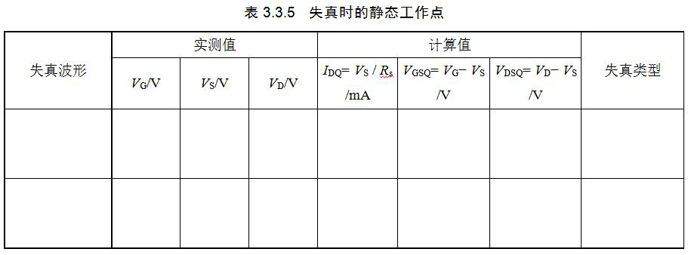

故障排除的方法

➢ 先静态、后动态、再指标；  
➢ 信号寻迹法  
➢ 看输入  
➢ 看输出

➢ 查电源**---**预留测试管脚与测试连线➢ 查连线**----**信号循迹法；对分搜索法➢ 查器件，查仪器**---**替代法；对比法；

**64**

三、选做内容

基于基础实验，可选做以下实验之一：

（1）MOS管特性曲线仿真（教材3.3.3实验任务1、

任务2）。

（2）共射放大电路设计、仿真与实现（教材4.2.6

设计任务）

验收要求：

➢ 预习报告（含设计电路**_**具体计算过程与

电路参数）

➢ 仿真测试结果（现场按要求仿真指定项

目！）

➢ 实际测试数据**---**验收表；

➢ 实际电路与测量

➢ **MOOC**课程模块四、模块六单元测验成

绩

➢ **\***选作实验报告与结果

66

下阶段：函数发生器设计

□基本实验：

满足一定幅度与频域要求的方波、三角波

产生电路的设计与实现（教材4.5.6设计任务）